**Comparator Circuit**

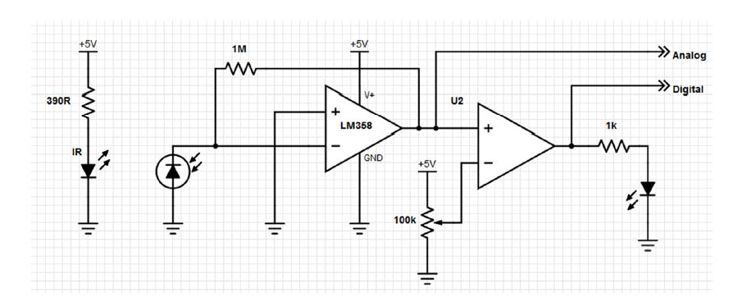**Photodiode**

[**http://my.element14.com/osram/sfh213-fa/photodiode-ir-filtered/dp/1212763**](http://my.element14.com/osram/sfh213-fa/photodiode-ir-filtered/dp/1212763)

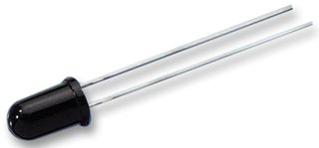

**LED**

[**http://my.element14.com/led-technology/l02r5000q1/led-5mm-green-3-7mcd-567nm/dp/1208851?st=led**](http://my.element14.com/led-technology/l02r5000q1/led-5mm-green-3-7mcd-567nm/dp/1208851?st=led)

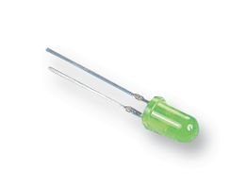

**LM358N**

[**http://my.element14.com/on-semiconductor/lm358n/op-amp-dual-1mhz-0-1v-us-8dip/dp/2295980?st=lm358**](http://my.element14.com/on-semiconductor/lm358n/op-amp-dual-1mhz-0-1v-us-8dip/dp/2295980?st=lm358)

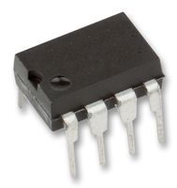

**POT**

<http://my.element14.com/bourns/3266w-1-103lf/pot-trimmer-10k-12-turn-3-pin/dp/9352651?st=pot>

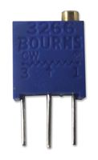

**Resistor**

<http://my.element14.com/vishay/mrs25000c1009fct00/resistor-thin-film-10r-0-6w-1/dp/9464026?st=resistor%20film>

